**BRAIN TUMOUR DETECTION USING CNN**

**Abstract**

A brain tumor occurs in human beings when a normal cell turns into an abnormal cell inside the brain. There are two types of brain tumors: benign tumors and malignant tumors. Nowadays machine learning and deep learning are playing a vital role in the field of medical and computer vision areas as this leads reduction in human judgment in the diagnosis and analysis of diseases in human beings. In brain tumor diagnosis we need high accuracy or else a minor error in diagnosis can cause a huge blunder. As deep learning is playing an important role in the medical field so in this paper we have implemented CNN and ANN of different configurations on binary classification which is based on machine learning with a given dataset of brain tumor MRI scans that depict a person is a brain tumor patient or not. This paper will focus on objective function value obtained by different CNN architectures with a minimum loss, maximum accuracy, and training time which can serve as a viable tool for physicians and the medical community to correctly identify the tumor patients.Experimental evaluations of the best architecture show that a maximum objective function value of 1.84, a validation accuracy score of 0.8275 is achieved & an AUC of 0.831 in the ROC curve to correctly identify whether a person is suffering from a brain tumor or not.

**Keywords:** Convolution neural network (CNN), Deep Learning, Neural Networks, Machine Learning, Artificial neural network (ANN).

**1.Introduction**

A major increase in mortality among children and adults is due to the brain tumor. A brain tumor is a condition in which there is a development of abnormal cells in our brain. As the skull is present around the brain is hard so due to this reason abnormal development leads to a problem in human beings. As brain tumors can be classified on the origin of tumor, malignancy, and growth pattern. A cancerous brain tumor is a major tumor that is also known as a malignant tumor it originates either from the brain or it is the result of any other cancer caused to a person like breast cancer. A benign brain tumor is another form of tumor that looks like a low level of cancer this states that the starting growth is very slow and symptoms of having this tumor are less compared to the malignant tumor [1]. In the U.S., 29000 peoples were diagnosed out of which nearly 13000 were suffering from primary malignant brain tumors each year according to the national brain tumor foundation(NBTF). One-quarter of all cancer death in children is caused by the brain tumor. The overall annual frequency of primary brain tumors in the U.S. is 11-12 per 100,000 peoples and for primary malignant brain tumors is 6-7 per 100,000. Over 4200 peoples with brain tumors were diagnosed in the U.K per year according to an estimation of 2007 and 1.6% i.e. 16 out of per 1000 cancer diagnosed were having brain cancer. Each year approximately 200 other types of tumors were diagnosed in the U.K. According to a report in 2007 total, 80271 cases were diagnosed in India with various types of tumors [2].

Benign and malignant are two classifications of brain tumors. As malignant is having non-uniformity in structure and it contains active cancer cells whereas in benign tumor there is uniformity and it doesn't contain any active cancer cells. Low-graded tumors i.e. benign tumors can be classified as gliomas and meningiomas and malignant tumors i.e. high-grade brain tumors can be classified as glioblastoma and astrocytomas [3]. There are many reasons due to which tumor causes and most of them are unknown this includes head injuries, hereditary syndromes, immune suppression electromagnetic fields prolonged exposure to ionizing radiations, or chemicals like vinyl chloride and formaldehyde. There are many symptoms of a brain tumor which include persistent headache, eyesight, hearing and speech problems, walking and balancing problems, memory lapse, nausea and vomiting, a problem in concentration, and seizures. For monitoring the anatomy, vascular supply, cellular structure of brain tumors we use Magnetic resonance imaging (MRI) which helps us to do diagnosis and have valuable treatment [4, 5].

MRI is a medical image processing that assists the medical diagnosers to diagnose and treat according to the condition of the patient. It is the process by which we can identify the disorders present inside the brain. It makes efficient use of the magnetic area, pulses, and computer visualizing for the area of bones, organs & structures of bodies of the patient for diagnoses. As viewing from a CT scan is much complicated so MRI offers the ability to understand the posterior brain brainstem efficiently. Segmentation plays an important role in finding the malicious region from the medical images which are complicated [6]. Magnetic resonance imaging (MRI) is having much application in imaging technique for the detection of brain tumors as it is a non-intrusive system, it can be utilized alongside other imaging modalities like magnetic resonance spectroscopy(MRS), computed tomography, and positron emission tomography(PET) so that we can get the more accurate structure of tumor [12,13]. For biopsy sampling MRI is used for tumor grading by pathologists it provides tumor location and we get information regarding the shape and size of the brain tumor by using MRI images [7].

In the medical field of brain tumor detection machine learning and deep learning provides a major role by providing better diagnosis [8-11]. Besides, deep learning models like convolutional neural networks (CNNs) & artificial neural networks(ANNs) have improved the classification of objects and the detection of images [14, 15]. As a deep learning paradigm, CNNs [16] can be used to extract more and exact features from different types of raw input images from the dataset which consist of different configurations of images [17]. In this paper, we discuss performance metrics achieved by different architectures configurations in which convolution neural networks (CNN) & artificial neural networks (ANN) are used in training the model. All CNN architectures gave different maximum accuracy, minimum loss & training time we calculated the objective function value of every architecture and then we have activated the neural network and evaluated the intermediate activation in CNN with Keras. By this brain tumor automatic diagnosis that is real-time deployment, we can achieve high accuracy with which we can save time and use computing power to detect tumors of patients efficiently. The rest of the paper is organized as follows:- 2. *Related work, 3. Methods and Data 4. Experimentation and Results, 5.Conclusions, and Future Work.* We evaluate different architectures of CNN and ANN to find out the best ideal architecture with maximum objective function value for the particular brain tumor dataset used in section 4.

**2. Related Work**

Nowadays most of the medical field is getting contribution from machine learning and deep learning techniques so that the works get easier and simplified for the medical workers. As most of the research papers are oriented towards deep learning techniques like CNN and ANN for solving problems regarding brain tumors [18-20]. Thillaikkarasi *et al.* (2019) performed brain tumor segmentation by using an algorithm of deep learning which includes CNN with M-SVM that will segment the tumor automatically and the MRI images that were used were modified by using the Laplacian of Gaussian filtering method (LoG) and Contrast Limited Adaptive Histogram Equalization (CLAHE) and used segmentation for helping in CNN architectures and they gained accuracy of 84% in the evaluation of the overall model [23]. As there are many types of a tumor so Ghassemi *et al.* (2020) used a new deep learning technique i.e. generative adversarial network (GAN) on the dataset for extracting the robust and structured feature from the MRI images and imported them into convolution layers which consist of three types of tumors namely meningioma, glioma, and pituitary tumors that had 3064 total images and achieved accuracies of 93.01% and 95.6% for introduced split and random split [21]. For instances, see the simple CNN technique used by Seetha *et al.* (2018) and they achieved an accuracy of 97.5% in brain tumor detection by using CNN architectures where the weight of neuron was very small as compared to normal deep learning architectures and they calculated the loss function by using gradient descent algorithm it was implemented on a dataset which was from 2015 by BRAIN TUMOR IMAGE SEGMENTATION BENCHMARK (BRATS) [22].

Fuzzy C-Means (FCM) was used by Mohsen H *et al*. (2017) for separating the tumourous and nontumorous patients & also used multilevel Discrete wavelet transform (DWT)for the extraction of wavelet features from the model. They used Sequential Minimal Optimization(SMO) for the classification method and Linear Discriminant Analysis(LDA) & KNN for the model which obtain high accuracy of 96.97% for analyzing the DNN based brain tumor classification as complexity was very high but the performance was very poor [24]. Classification accuracy of 81% was obtained by Pashaei *et al.* where he used 3*3 size of all filters and the model had five layers [25]. Performance of CNN features of the model by Pashaei was increased by using the extreme learning machines (ELM) techniques as results recall value of pituitary tumor was very high and meningioma was very low which unbiased the model. Capsule Network(CapsNet), was introduced into brain tumor detection that was used for utilizing the relating relationship between the tumor and its surrounding tissues. This was a modified form of CNN architectures which was introduced by Afshar *et al.* [26]. Transfer learning plays important role in the classification of tumors which was applied on content-based image retrieval (CBIR) and the evaluation was performed on a dataset that was available publicly and Swati *et al.* obtained well good results [27]. We can obtain great experimental values with pre-trained models. Jain *et al.* used the VGG-16 model which was pre-trained for the detection of Alzheimer's diseases from the images of MRI [28].

Although there are many techniques by which we can detect brain tumors in patients but we have several limitations but the main reason behind this detection is that the lack of dataset. As many radiologists face issues regarding this binary classification that enough information or data is not provided on sources for detection.

**3. Methods and Data**

In this section, we will discuss the methodology we have used in the classification process of Brain tumors using MRI images whether a person is suffering from a tumor or not. We also specify the dataset that we have used for detection and also the technology with which we have done the experimentation and computations re also mentioned in this section. This section maps out as follows 3.1 *Dataset Used*,3.2 *Image Augmentation*, 3.3 *Artificial Neural Network(ANN)*, 3.4 *Convolutional Neural Network(CNN)*,3.5 *Software, and Hardware*.

**3.1 Dataset Used**

The MRI images for Brain Tumor Detection of patients were collected from Kaggle by Navoneel Chakrabarty. He collected all the images from internet sources and gathered around 253 images [36]. A sample difference between a positive and a negative patient is shown in Fig.1. Table 1 describes the amount of MRI images taken for training and testing of the model.

**Table 1. Dataset distribution and splitting of images taken into training and testing**

|  |  |  |
| --- | --- | --- |
|  | **Brain Tumor Patient** | **Normal** |
| **Training** | 1073 | 781 |
| **Testing** | 234 | 137 |
| **Total** | 1307 | 918 |

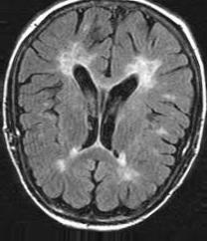 **Normal Brain Tumor Patient**

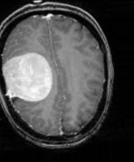

**Fig 1. (L) MRI of a normal person, and (R) of a brain tumor patient.**

**The abnormal cell can be seen in the Tumor positive MRI image**

**3.2 Image Augmentation**

More accuracy can be gained only if we have a large number of datasets for training our model. In this case, data augmentation plays an essential role in increasing the data of the dataset. Data augmentation plays an important role in deep learning we can observe in various research papers regarding image augmentation it plays an important role in datset[29-35]. If our model is having training on the large number of images the accuracy and stability of our model i.e. .hdf5 file will be more accurate and efficient. Image augmentation works on different parameters like shear, zoom, rescale, flipping, whitening transforms random rotations and shifts. In our approach, we rotate, shear, brightness increment, horizontal and vertical flipping, width, and height shifting in the training images for increasing and for having a wider variety of our training data.

**3.3 Artificial Neural Network (ANN)**

In Deep Learning, ANN plays an important role as a backbone in deep neural network .ANN is having a wide range of application in the field of deep learning it can be used in training models of Speech Recognition[37-42], Face Recognition [43-48], Signature Verification Application [49-53]. ANN are powerful neural networks that are simple and they are highly interconnected with each other by which they transfer information by their dynamic state of response to any external user inputs. They are made up of multiple nodes that are just like biological neurons of the human brain. Links are connecting medium between the neurons and they can interact with each with the help of links. Nodes take up the input data and perform the various operations on the data and then the result of these operations is passed to other neurons and the output at every node is mentioned as activation value.

Mathematically, we can represent as $input→x$ then transforming a set $S ∁ AE^{x}$ of input signals where

(a $x$– neuron on $S$) is a function.

|  |  |  |
| --- | --- | --- |
|  | $$U :AE^{x}× S ∋\left(\vec{b },\vec{c }\right)→U\left(\vec{b },\vec{c }\right)=f\left(<\vec{b },\vec{c }>\right)∋AE$$ | (1) |

where $\vec{b}$ is a weight vector ;

< . , . > is a real scalar product,

And we have

$f :AE→Æ$ is called as activation function of the neuron in ANN layers. If $f$ is a linear operator then the neuron will be linear.

A function;

|  |  |  |
| --- | --- | --- |
|  | $U^{*} :=U\left(\vec{b },. \right) : S∋ \vec{c }→U^{*} \left(\vec{c }\right)∈AE$ | (2) |

is called a model that is trained on $x-$ neuron on $S$.

Bounded functions are mostly used for representing the activation functions in output layers. The above equations show that a two vector variable are having neuron as a function whereas comparing to trained neuron, there is a weight vector fit in trained neurons therefore we can state that a mapping of only one vector variable is known as a trained neuron. Activation functions are the most important part of ANN. There are numerous types of activation functions such as Sigmoid, ReLu, TanH, Softmax, and Swish are commonly used. In ANN most interesting thing is that the output of any neuron works as an input for other neurons in process of deploying the model.

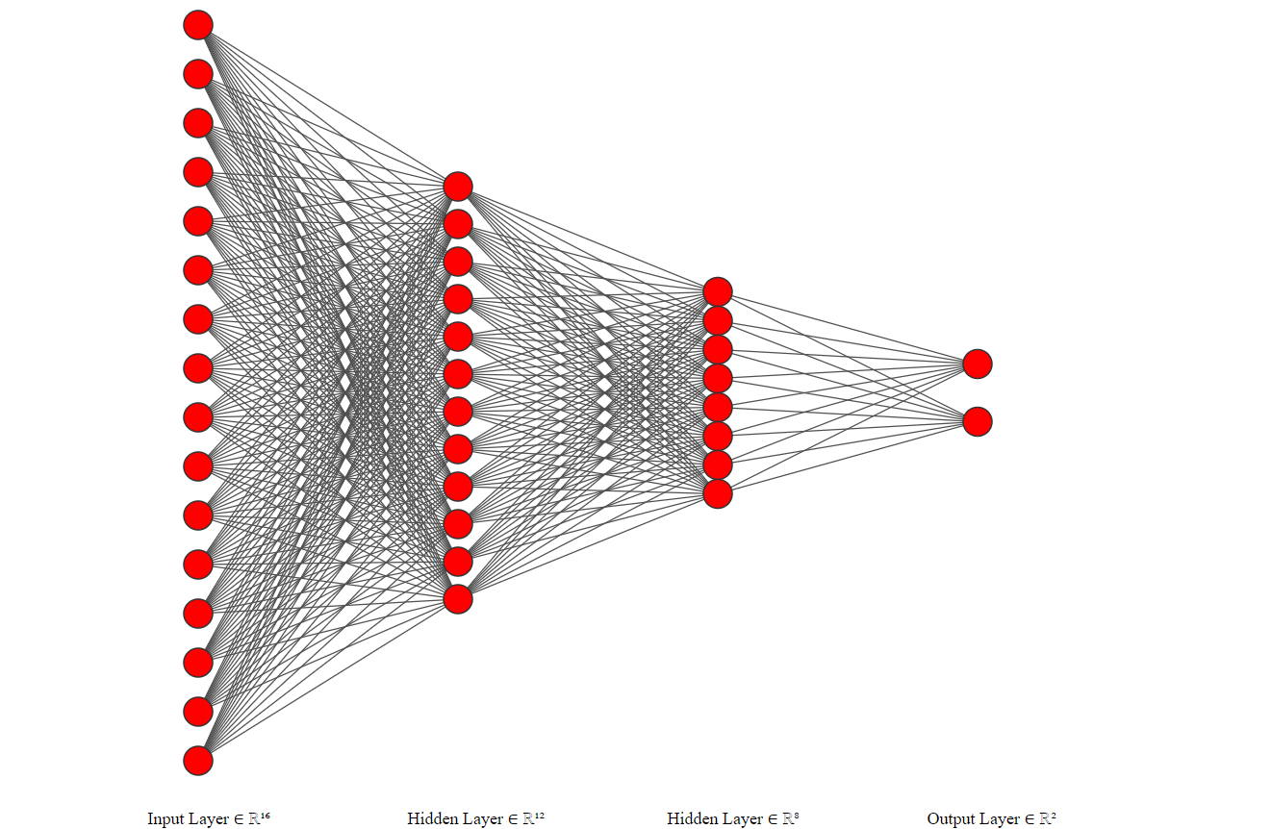

**Fig. 2 . Artificial Neural Network (ANN).**

Above Fig. 2 shows the connection of ANN layers with each other in order of Left to Right in a layer-wise manner i.e. {16, 12, 8, 2 }. The input layer consists of 16 nodes where the inputs are provided and they are attached with two hidden layers having nodes 12 and 8 respectively. The output layer consists of 2 nodes as a person will either suffer from a tumor or not it is a binary case so softmax function comes into play in the output layer which will help for summing up the values to unity.

**3.4 Convolutional Neural Network (CNN)**

Image recognition and classification is a major field in machine learning and when the image comes into role then Convolutional Neural Networks are the backbone in algorithms of deep learning. From the learning of the model to calculating the results, CNN plays an important role. More number of layers with parameters will give more accurate and stable results. CNN consists of two parameters namely weights and biases. More layers will give more accuracy but a minimum of three layers are compulsory on the implementation of CNN layers i.e. Convolution Layer, Pooling Layer, and Fully Connected Layer. Each layer will perform a different task on the input dataset and they have several different parameters that can be optimized. CNN have many applications in day-today like decoding facial recognition[54-57], Analyzing Documents[58-59], Understanding Climate[60-61], Predicting earthquakes[62-64] and many more[65-70].

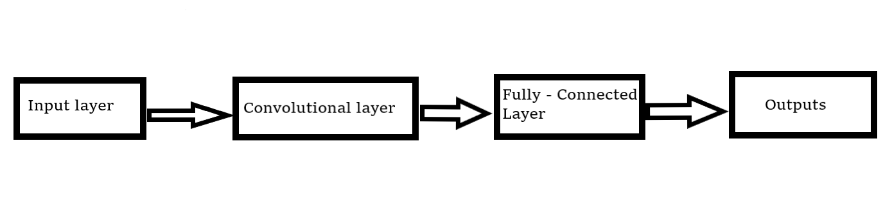

**Fig. 3. Convolutional Neural Networks (CNN)**

Fig. 3 shows a basic block diagram of CNN architecture that can be used in any model for the dataset. Convolutional networks are mainly inspired or attracted to the pattern of images. They understand the parameters by itself and extract the right features for training the model and we need not provide it. As pixels are present in every picture we analyze the results by filters that consist of weights, kernels, and features.detecting the edges of the images are a major part, and filters are used to detect it. It will help in filtering out unwanted information to enhance image filters and quality. Filters are also known as 2-D matrices or kernels.

CNN architectures are equivariant which can be represented as

|  |  |  |
| --- | --- | --- |
|  | $$a\left(b\left(x\right)\right)=b(a\left(x\right))$$ | (3) |

If there is any image ‘I’, $a$ is a convolutional operation and is $b$ image translation operation.

Convolutional is equivariant to translation operation. The equation states that first convolving the image and then translating the image or vice versa both will lead to the same result at the end. Equivariant helps its sharing parameters. A pooling layer is present thereafter convolutional layer which operates independently on each of the feature maps. Pooling layer reduces the spatial sizes simultaneously so that the computation and parameters present in the network are reduced. Most commonly max pooling is used in the pooling layer section.

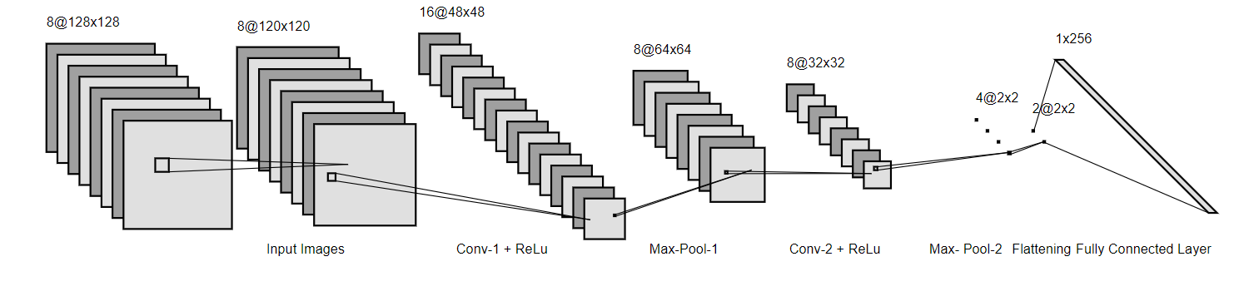

**Fig. 4. Convolutional Architecture of 2- layered CNN model**

After max-pooling flattening is the most essential part as it converts all the parameters and data that are multi-dimensional into a 1-D array format which makes work easier for connecting all the layers. At last full connection of neurons is there at the end of CNN where the ReLu function plays an important in the full connection of CNN architecture. Fig. 4 shows all connections and different layers in 2 –layered full CNN neural network.

**3.5 Software and Hardware**

Various CNN architectures trained for this machine learning analysis Python 3 with the Keras and TensorFlow were used with a jupyter notebook. Hardware workstation is with Intel i5 $8^{th}$ generation and 16 GB RAM.

**4. Experimentation and Results**

In this section, we elaborate everything regarding experimentation performed on the dataset through different architectures which consist of different parameters and we select the best model for classification which is more stable in performance. We divide this section as 4.1 *Experiments and Analysis*, 4.2 *Results of Selected Architecture.*

**4.1. Experiments and Analysis**

We implemented different parameters in different CNN architectures for finding the best model. For the different implementations, we had various parameters such as the number of artificial layers and convolutional layers, regularization parameters like L1, L2, Batch normalization and Dropout, image input sizes, kernel sizes, pooling matrix sizes, and analogize all the architectures on a basis of maximum accuracy achieved during training and least cross-entropy loss encountered during training. The best model was selected based on objective function value which can be expressed as

|  |  |  |
| --- | --- | --- |
|  | $$Objective Function Value=\frac{MVA}{TT+LVCEL }$$ | (3) |

Table 4 contains all the information regarding all the 15 different CNN architectures with maximum accuracy, least cross-entropy loss with training time in seconds for the training of the model, and Table 3 consists of all meaning of abbreviations used in Table 4. Fig. 4 tells us about structure regarding each architecture based on LVCEL, MVA, and TT. Fig. 6 (a) plots the training accuracy and (b) plots the cross-entropy loss of each architecture concerning each epoch. From table 4 we observed that architecture 4 performed poorly concerning MVA and LVCEL as it had the least objective function value of 0.6073. This might be happened due to batch normalization as when BatchNorm is implemented it reduces training time with the drop in accuracy which leads to a fall in objective function value of this architecture and it restricted the model from building relationships with the dataset. We also noticed a directly proportional connection between the training time and our different CNN architectures. As in architectures 5, 6, and 13 we have fed image size of (64,64) which reduced training time drastically so we can conclude that TT is highly dependent upon IS. More number of layers the computational task increases on training the models and load on computational power in training the neural network increases when the intensive task is performed. Earlier, as we have mentioned regarding TT (Fig.5 (c)) changes drastically when there is an increase or decrease in architecture size i.e. when we increase or decrease the layers of CNN and ANN or apply different parameters but in Table 4 LVCEL and MVA there is no drastic change. However, the maximum objective function value was achieved by the 13th model which was 1.84 and the minimum objective function value was scored by the 4th model as 0.6073. By this, we can finally conclude that simple architecture performs better and are more stable and accurate. Either model will overfit or underfit if we implement more features and layers. For further consideration, we have taken architecture 13 as an ideal model to evaluate model performance on the brain MRI dataset in the next section.

**Table 3. Abbreviations used in Table 4.**

|  |  |
| --- | --- |
| **Abbreviation** | **Meaning** |
| **CL** | The number of CNN Layers in an architecture. |
| **AL** | The number of ANN Layers in an architecture. |
| **L1** | Level 1 regularization |
| **L2** | Level 2 regularization |
| **BN** | Batch Normalization |
| **DO** | Dropout |
| **IS** | Input Size of image (64x64 or 128x128) |
| **FD** | Features Detected in a convolutional layer, layer-wise. |
| **KS** | Kernel Sizes for each convolutional layer, layer-wise. |
| **PS** | Pooling Sizes followed by every convolutional layer always assumed to be a square matrix. |
| **TT** | Time Taken in seconds to train the model. |
| **LVCEL** | Least Validation Cross-Entropy Loss achieved during training. |
| **MVA** | Maximum Validation Accuracy was achieved during training. |

**Table 4. Performance of 15 different CNN architectures on various parameters.**

|  |  |  |  |  |  |  |  |  |  |  |  |  |  |
| --- | --- | --- | --- | --- | --- | --- | --- | --- | --- | --- | --- | --- | --- |
| S. No. | CL | AL | Regularizations | | | | IS | FD | KS | PS | **LVCEL** | **MVA** | **TT** |
|  |  |  | L1 | L2 | BN | DO |  |  |  |  |  |  |  |
| 1 | 2 | 3 | ✖ | ✖ | ✖ | ✖ | (128,128) | {64,32} | {9,3} | {4,2} | 0.3339 | 0.8518 | 195 |
| 2 | 2 | 4 | ✖ | ✖ | ✖ | ✖ | (128,128) | {64,32} | {9,3} | {4,2} | 0.3710 | 0.8491 | 209 |
| 3 | 2 | 4 | ✖ | ✖ | ✔ | ✔ | (128,128) | {64,32} | {9,3} | {4,2} | 0.3800 | 0.8491 | 216 |
| 4 | 2 | 4 | ✖ | ✖ | ✔ | ✖ | (128,128) | {64,32} | {9,3} | {4,2} | 0.3801 | 0.8329 | 219 |
| 5 | 2 | 4 | ✖ | ✖ | ✖ | ✔ | (64,64) | {64,32} | {9,3} | {4,2} | 0.5461 | 0.7358 | 131 |
| 6 | 2 | 2 | ✖ | ✖ | ✖ | ✖ | (64,64) | {64,32} | {9,3} | {4,2} | 0.5651 | 0.7224 | 134 |
| 7 | 2 | 3 | ✖ | ✖ | ✔ | ✔ | (128,128) | {64,32} | {9,3} | {4,2} | 0.3281 | 0.8464 | 220 |
| 8 | 3 | 4 | ✖ | ✖ | ✔ | ✖ | (128,128) | {128,64,32} | {9,6,3} | {4,2,2} | 0.3900 | 0.8518 | 211 |
| 9 | 3 | 5 | ✖ | ✔ | ✖ | ✖ | (128,128) | {128,64,32} | {9,6,3} | {4,2,2} | 0.3811 | 0.8383 | 196 |
| 10 | 4 | 4 | ✔ | ✖ | ✖ | ✔ | (128,128) | {128,64,32,16} | {9,6,3,3} | {4,2,2,2} | 0.4100 | 0.8167 | 192 |
| 11 | 4 | 5 | ✔ | ✔ | ✖ | ✖ | (128,128) | {128,64,32,16} | {9,6,3,3} | {4,2,2,2} | 0.3486 | 0.8652 | 181 |
| 12 | 4 | 5 | ✖ | ✖ | ✖ | ✖ | (128,128) | {128,64,32,16} | {9,6,3,3} | {4,2,2,2} | 0.4164 | 0.8571 | 180 |
| **13** | **4** | **5** | **✖** | **✖** | **✖** | **✖** | **(64,64)** | **{64,32,32,16}** | **{9,6,3,3}** | **{2,2,2,2}** | **0.4480** | **0.8275** | **106** |
| 14 | 5 | 5 | ✖ | ✖ | ✖ | ✖ | (128,128) | {128,64,64,32,16} | {9,6,6,3,3} | {2,2,2,2,2} | 0.4012 | 0.8464 | 184 |
| 15 | 5 | 6 | ✖ | ✖ | ✖ | ✖ | (128,128) | {128,64,64,32,16} | {9,6,6,3,3} | {2,2,2,2,2} | 0.4040 | 0.8356 | 182 |

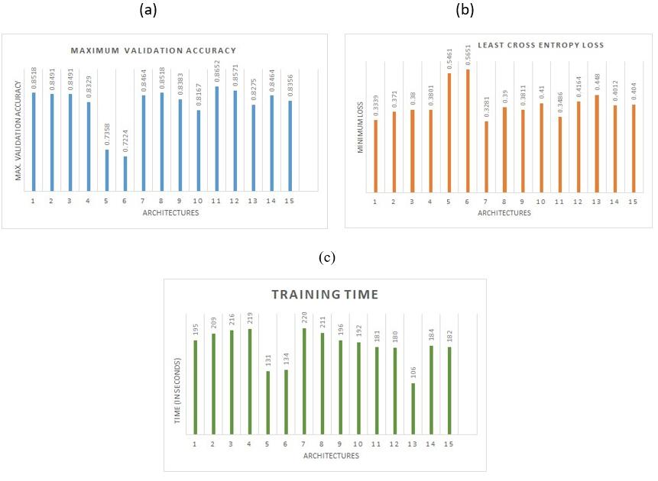

**Fig. 5(a) Maximum Validation Accuracy (MVA) for each architecture. (b) Least Cross-Entropy Loss (LVCEL) for each architecture. (c) Training Times (TT) or each architecture.**

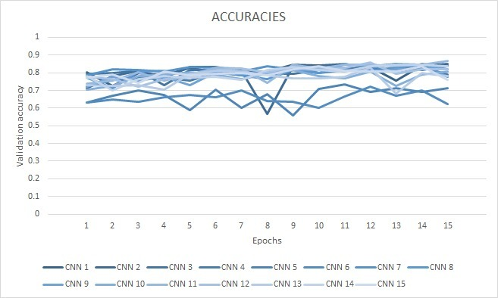

**(a)**

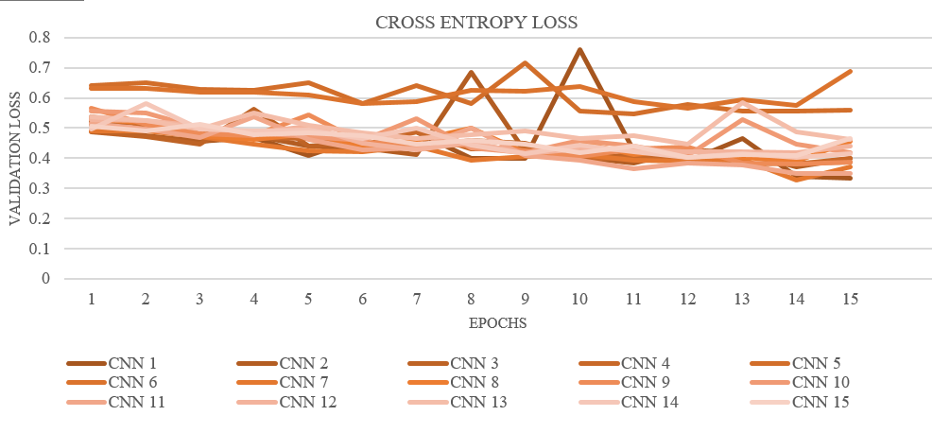

**(b)**

Fig 6. (a) Validation accuracy training curve for each architecture per epoch. (b) Validation cross-entropy loss training curve for each architecture per epoch.

4.2. Result of Selected Architecture

We have selected architecture 13 as the model performance was good and achieved a higher objective function value. As the evaluation metrics, we use the confusion matrix and calculate the precision, recall, and F1 score.

|  |  |  |
| --- | --- | --- |
|  | $$Precision=TP/(TP+FP)$$ | (4) |

|  |  |  |
| --- | --- | --- |
|  |  | (5) |

|  |  |  |
| --- | --- | --- |
|  |  | (6) |

Where TP, TN, FP, and FN are True Positive, True Negative, False Positive, and False Negative respectively. Fig.7 illustrates the confusion matrix of the selected model where augmented testing was done on 371 images but for evaluation of confusion matrix and calculation, we have used 51 images for calculating the accuracy and stability of our model. A dataset was small we implemented data augmentation to enlarge our dataset and for testing, we cannot use augmented images so we considered 51 images that are not augmented then testing was performed on architecture.

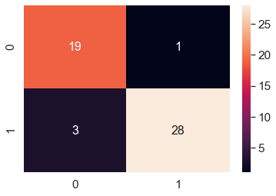

Fig.7. The confusion matrix for architecture 13 (see Table 4 ). From the figure, we see that TP =28, TN=19 FP =3 and FN= 1.

From equation 3,4 and 5 we calculated $Precision=0.90322$, $Recall=0.9655,$ and $F1-Score=0.93331$. All three metrics are above 90% this indicates that our model was accurate and performed excellently in diagnosing the positive brain tumor and also negative cases. Moreover, the ROC curve is illustrated in Fig. 8 where the area under the curve (AUC) was found to be 0.737 which is good. These metrics are good and are comparable with various architectures based on Brain tumor detection.

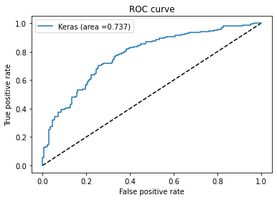

Fig 8. The receiver-operating characteristics (ROC) curve for 13th CNN architecture. The area under the curve is calculated to be 0.737 units.

5.Conclusions and Future Work

In this paper, we make an effort to find out the best approach for Brain Tumor Detection Using MRI images by comparing all the performance by 15 different CNN architecture. Based on objective function value we selected the ideal model which is easy to train, detecting tumor faster as compared to other architectures, and training time was less with more accuracy and stability. The metrics of selected architecture compared to other ones are simpler as if architectures get complex the training time increases and there is no such increase in accuracy and quality of the model. As learned from the findings in research work, we recommend that the simpler architectures perform best and are more stable and reliable than the complex ones. We admit that architecture 13 can perform better and can gain higher level accuracy and stability if we do small adjustments and experimented upon more. Future work on brain tumor detection can also be done through ResNet and different architectures and models can be trained for getting better results in less time so that they can be taken along with Brain MRI images for better diagnosis of the tumor.

|  |  |
| --- | --- |
| **Abbreviations** | |
| AL | Artificial neural network Layers |
| ANN | Artificial Neural Network |
| AUC | Area Under Curve |
| BN | Batch Normalization |
| CL | Convolutional Layers |
| CNN | Convolutional Neural Network |
| MRI | Magnetic resonance imaging |
| DO | Dropout |
| FC | Full Connection |
| FD | Features Detected |
| IS | Input Size |
| KS | Kernel Size |
| L1 | L1 regularization |
| L2 | L2 regularization |
| LVCEL | Least Validation Cross Entropy Loss |
| MVA | Maximum Validation Accuracy |
| PS | Pooling Size |
| TT | Training Time |

References –

1. Bhattacharyya, D., & Kim, T. H. (2011, April). Brain tumor detection using MRI image analysis. In *International Conference on Ubiquitous Computing and Multimedia Applications* (pp. 307-314). Springer, Berlin, Heidelberg.
2. Logeswari, T., & Karnan, M. (2009).Improved implementation of brain tumor detection using segmentation based on soft computing. *Journal of Cancer Research and Experimental Oncology*, *2*(1), 006-014.
3. Bahadure, N. B., Ray, A. K., & Thethi, H. P. (2017). Image analysis for MRI based brain tumor detection and feature extraction using biologically inspired BWT and SVM. *International journal of biomedical imaging*, *2017*.
4. Majos, C., Julia-Sape, M., Alonso, J., Serrallonga, M., Aguilera, C., Acebes, J. J., ... & Gili, J. (2004). Brain tumor classification by proton MR spectroscopy: comparison of diagnostic accuracy at short and long TE. *American Journal of Neuroradiology*, *25*(10), 1696-1704.
5. Lukas, L., Devos, A., Suykens, J. A., Vanhamme, L., Howe, F. A., Majos, C., ... & Van Huffel, S. (2004). Brain tumor classification is based on long echo proton MRS signals. *Artificial intelligence in medicine*, *31*(1), 73-89.
6. Rammurthy, D., & Mahesh, P. K. (2020). Whale Harris hawks optimization-based deep learning classifier for brain tumor detection using MRI images. *Journal of King Saud University-Computer and Information Sciences*.
7. Naser, M. A., & Deen, M. J. (2020). Brain tumor segmentation and grading of lower-grade glioma using deep learning in MRI images. *Computers in Biology and Medicine*, 103758.
8. Soltaninejad, M., Yang, G., Lambrou, T., Allinson, N., Jones, T. L., Barrick, T. R., ... & Ye, X. (2017). Automated brain tumor detection and segmentation using superpixel-based extremely randomized trees in FLAIR MRI. *International journal of computer-assisted radiology and surgery*, *12*(2), 183-203.
9. Mallard, J. R., Fowler, J. F., & Sutton, M. (1961). V. Brain Tumour Detection using Radioactive Arsenic. *The British Journal of Radiology*, *34*(405), 562-568.
10. Goswami, S., & Bhaiya, L. K. P. (2013, April). Brain tumor detection using unsupervised learning based neural network. In *2013 International Conference on Communication Systems and Network Technologies* (pp. 573-577). IEEE.
11. Sharma, K., Kaur, A., & Gujral, S. (2014). Brain tumor detection-based on machine learning algorithms. *International Journal of Computer Applications*, *103*(1), 7-11.
12. Bauer, S., Wiest, R., Nolte, L. P., & Reyes, M. (2013). A survey of MRI-based medical image analysis for brain tumor studies. *Physics in Medicine & Biology*, *58*(13), R97.
13. DeAngelis, L. M. (2001). Brain tumors. *New England journal of medicine*, *344*(2), 114-123.
14. Yan, C., Xie, H., Yang, D., Yin, J., Zhang, Y., & Dai, Q. (2017). Supervised hash coding with deep neural network for environment perception of intelligent vehicles. *IEEE transactions on intelligent transportation systems*, *19*(1), 284-295.
15. Sentas, A., Tashiev, I., Kucukayvaz, F., Kul, S., Eken, S., Sayar, A., & Becerikli, Y. (2020). Performance evaluation of a support vector machine and convolutional neural network algorithms in real-time vehicle type and color classification. *Evolutionary Intelligence*, *13*(1), 83-91.
16. LeCun, Y., Kavukcuoglu, K., & Farabet, C. (2010, May). Convolutional networks and applications in vision. In *Proceedings of 2010 IEEE international symposium on circuits and systems* (pp. 253-256). IEEE.
17. Abd-Ellah, M. K., Awad, A. I., Khalaf, A. A., & Hamed, H. F. (2018). Two-phase multi-model automatic brain tumor diagnosis system from magnetic resonance images using convolutional neural networks. *EURASIP Journal on Image and Video Processing*, *2018*(1), 97.
18. Iqbal, S., Ghani, M. U., Saba, T., & Rehman, A. (2018). Brain tumor segmentation in multi‐spectral MRI using convolutional neural networks (CNN). *Microscopy research and technique*, *81*(4), 419-427.
19. Abdullah, A. A., Chize, B. S., & Zakaria, Z. (2012). Design of cellular neural network (CNN) simulator based on MatLab for brain tumor detection. *Journal of Medical Imaging and Health Informatics*, *2*(3), 296-306.
20. Pereira, S., Pinto, A., Alves, V., & Silva, C. A. (2016). Brain tumor segmentation using convolutional neural networks in MRI images. *IEEE transactions on medical imaging*, *35*(5), 1240-1251.
21. Ghassemi, N., Shoeibi, A., & Rouhani, M. (2020). A deep neural network with generative adversarial networks pre-training for brain tumor classification based on MR images. *Biomedical Signal Processing and Control*, *57*, 101678.
22. Seetha, J., & Raja, S. S. (2018). Brain tumor classification using convolutional neural networks. *Biomedical & Pharmacology Journal*, *11*(3), 145.
23. Thillaikkarasi, R., & Saravanan, S. (2019). An enhancement of deep learning algorithm for brain tumor segmentation using kernel-based CNN with M-SVM. *Journal of medical systems*, *43*(4), 84.
24. Mohsen, H., El-Dahshan, E. S. A., El-Horbaty, E. S. M., & Salem, A. B. M. (2018). Classification using deep learning neural networks for brain tumors. *Future Computing and Informatics Journal*, *3*(1), 68-71.
25. Pashaei, A., Sajedi, H., & Jazayeri, N. (2018, October). Brain tumor classification via convolutional neural network and extreme learning machines. In the *2018 8th International conference on computer and knowledge engineering (ICCKE)* (pp. 314-319). IEEE.
26. Afshar, P., Plataniotis, K. N., & Mohammadi, A. (2019, May). Capsule networks for brain tumor classification based on MRI images and coarse tumor boundaries. In *ICASSP 2019-2019 IEEE International Conference on Acoustics, Speech and Signal Processing (ICASSP)* (pp. 1368-1372). IEEE.
27. Swati, Z. N. K., Zhao, Q., Kabir, M., Ali, F., Ali, Z., Ahmed, S., & Lu, J. (2019). Content-based brain tumor retrieval for MR images using transfer learning. *IEEE Access*, *7*, 17809-17822.
28. Jain, R., Jain, N., Aggarwal, A., & Hemanth, D. J. (2019). Convolutional neural network-based Alzheimer’s disease classification from magnetic resonance brain images. *Cognitive Systems Research*, *57*, 147-159.
29. Frid-Adar, M., Diamant, I., Klang, E., Amitai, M., Goldberger, J., & Greenspan, H. (2018). GAN-based synthetic medical image augmentation for increased CNN performance in liver lesion classification. *Neurocomputing*, *321*, 321-331.
30. Bloice, M. D., Stocker, C., & Holzinger, A. (2017). Augmentor: an image augmentation library for machine learning. *arXiv preprint arXiv:1708.04680*.
31. Bloice, M. D., Roth, P. M., & Holzinger, A. (2019). Biomedical image augmentation using Augmentor. *Bioinformatics*, *35*(21), 4522-4524.
32. Salehinejad, H., Valaee, S., Dowdell, T., & Barfett, J. (2018, April). Image augmentation using radial transform for training deep neural networks. In *2018 IEEE International Conference on Acoustics, Speech and Signal Processing (ICASSP)* (pp. 3016-3020). IEEE.
33. Mikołajczyk, A., & Grochowski, M. (2018, May). Data augmentation for improving deep learning in image classification problems. In *2018 international interdisciplinary Ph.D. workshop (IIPhDW)* (pp. 117-122). IEEE.
34. Perez, L., & Wang, J. (2017). The effectiveness of data augmentation in image classification using deep learning. *arXiv preprint arXiv:1712.04621*.
35. Wang, J., & Perez, L. (2017). The effectiveness of data augmentation in image classification using deep learning. *Convolutional Neural Networks Vis. Recognit*, *11*.
36. Chakrabarty,N.(2019, April).Brain MRI Images for Brain tumor Detection, Version 1. Retrieved September 02, 2020, from https://www.kaggle.com/navoneel/brain-mri-images-for-brain-tumor-detection
37. Neto, J., Almeida, L., Hochberg, M., Martins, C., Nunes, L., Renals, S., & Robinson, T. (1995). Speaker-adaptation for hybrid HMM-ANN continuous speech recognition system.
38. Paul, A. K., Das, D., & Kamal, M. M. (2009, February). Bangla speech recognition system using LPC and ANN. In *2009 Seventh International Conference on Advances in Pattern Recognition* (pp. 171-174). IEEE.
39. Trentin, E., & Gori, M. (2001). A survey of hybrid ANN/HMM models for automatic speech recognition. *Neurocomputing*, *37*(1-4), 91-126.
40. Williams, G., & Renals, S. (1997). Confidence measures for hybrid HMM/ANN speech recognition.
41. Jaitly, N., Nguyen, P., Senior, A., & Vanhoucke, V. (2012). Application of pre-trained deep neural networks to large vocabulary speech recognition.
42. Wijoyo, S., & Wijoyo, S. (2011). Speech recognition using linear predictive coding and artificial neural network for controlling the movement of a mobile robot. In *Proceedings of 2011 International Conference on Information and Electronics Engineering (ICIEE 2011)* (pp. 28-29).
43. MageshKumar, C., Thiyagarajan, R., Natarajan, S. P., Arulselvi, S., & Sainarayanan, G. (2011, March). Gabor features and LDA-based face recognition with ANN classifier. In *2011 International Conference on Emerging Trends in Electrical and Computer Technology* (pp. 831-836). IEEE.
44. Deshpande, N. T., & Ravishankar, S. (2017). Face Detection and Recognition using Viola-Jones algorithm and Fusion of PCA and ANN. *Advances in Computational Sciences and Technology*, *10*(5), 1173-1189.
45. Goyani, M., Dhorajiya, A., & Paun, R. (2011). Performance analysis of FDA based face recognition using correlation, ANN, and SVM. *International Journal of Artificial Intelligence and Neural Networks*, *1*(1), 108-111.
46. Patil, A. A., & Maka, L. (2015). User Recognition Based on Face using Local Binary Pattern (LBP) with Artificial Neural Network (ANN). *International Journal of Ethics in Engineering & Management Education*, *2*(5), 32-35.
47. Fan, X., & Verma, B. (2005, August). A comparative experimental analysis of separate and combined facial features for GA-ANN based technique. In *Sixth International Conference on Computational Intelligence and Multimedia Applications (ICCIMA'05)* (pp. 279-284). IEEE.
48. Bordoloi, H., & Sarma, K. K. (2009). Face recognition with image rotation detection, correction, and reinforced decision using ANN. *International Journal of Electrical and Electronics Engineering*, *3*(7), 1205-1212.
49. Quan, Z. H., & Liu, K. H. (2007). Online signature verification is based on the hybrid hmm/ann model. *International Journal of Computer Science and Network Security*, *7*(3), 313-322.
50. Al-Shoshan, A. I. (2006, July). Handwritten signature verification using image invariants and dynamic features. In *International Conference on Computer Graphics, Imaging and Visualisation (CGIV'06)* (pp. 173-176). IEEE.
51. Karouni, A., Daya, B., & Bahlak, S. (2011). Offline signature recognition using neural networks approach. *Procedia Computer Science*, *3*, 155-161.
52. Deshmukh, V. M., & Murab, S. A. (2012). Signature recognition & verification using ANN. *International Journal of Innovative Technology and Exploring Engineering*, *1*(6), 6-8.
53. Quan, Z. H., Huang, D. S., Liu, K. H., & Chau, K. W. (2007, August). A hybrid hmm/ann based approach for online signature verification. In *2007 International Joint Conference on Neural Networks* (pp. 402-405). IEEE.
54. Sajjad, M., Zahir, S., Ullah, A., Akhtar, Z., & Muhammad, K. (2019). Human behavior understanding in big multimedia data using CNN based facial expression recognition. *Mobile networks and applications*, 1-11.
55. Fan, Y., Lu, X., Li, D., & Liu, Y. (2016, October). Video-based emotion recognition using CNN-RNN and C3D hybrid networks. In *Proceedings of the 18th ACM International Conference on Multimodal Interaction* (pp. 445-450).
56. Chen, J. C., Patel, V. M., & Chellappa, R. (2016, March). Unconstrained face verification using deep CNN features. In the *2016 IEEE winter conference on applications of computer vision (WACV)* (pp. 1-9). IEEE.
57. Ramaiah, N. P., Ijjina, E. P., & Mohan, C. K. (2015, February). Illumination invariant face recognition using convolutional neural networks. In *2015 IEEE International Conference on Signal Processing, Informatics, Communication, and Energy Systems (SPICES)* (pp. 1-4). IEEE.
58. Kim, D., Park, C., Oh, J., Lee, S., & Yu, H. (2016, September). Convolutional matrix factorization for document context-aware recommendation. In *Proceedings of the 10th ACM conference on recommender systems* (pp. 233-240).
59. Kim, D., Park, C., Oh, J., & Yu, H. (2017). Deep hybrid recommender systems via exploiting document context and statistics of items. *Information Sciences*, *417*, 72-87.
60. Racah, E., Beckham, C., Maharaj, T., Kahou, S. E., Prabhat, M., & Pal, C. (2017). extreme weather: A large-scale climate dataset for semi-supervised detection, localization, and understanding of extreme weather events. In *Advances in Neural Information Processing Systems* (pp. 3402-3413).
61. Feldman, L., Maibach, E. W., Roser-Renouf, C., & Leiserowitz, A. (2012). The climate on cable: The nature and impact of global warming coverage on Fox News, CNN, and MSNBC. *The International Journal of Press/Politics*, *17*(1), 3-31.
62. Oh, B. K., Park, Y., & Park, H. S. (2020). Seismic response prediction method for building structures using a convolutional neural network. *Structural Control and Health Monitoring*, *27*(5), e2519.
63. Jozinovic, D., Lomax, A., Stajduhar, I., & Michelini, A. (2020). Rapid prediction of the earthquake ground shaking intensity using raw waveform data and a convolutional neural network. *Geophysical Journal International*, *222*(2), 1379-1389.
64. Nguyen, V. Q., Yang, H. J., Kim, K., & Oh, A. R. (2017, April). Real-time earthquake detection using convolutional neural network and social data. In *2017 IEEE Third International Conference on Multimedia Big Data (BigMM)* (pp. 154-157). IEEE.
65. Van Grinsven, M. J., van Ginneken, B., Hoyng, C. B., Theelen, T., & Sánchez, C. I. (2016). Fast convolutional neural network training using selective data sampling: Application to hemorrhage detection in color fundus images. *IEEE transactions on medical imaging*, *35*(5), 1273-1284.
66. Crounse, K. R., Yang, T., & Chua, L. O. (1996, June). Pseudo-random sequence generation using the CNN universal machine with applications to cryptography. In *1996 Fourth IEEE International Workshop on Cellular Neural Networks and their Applications Proceedings (CNNA-96)* (pp. 433-438). IEEE.
67. Hirasawa, T., Aoyama, K., Tanimoto, T., Ishihara, S., Shichijo, S., Ozawa, T., ... & Tada, T. (2018). Application of artificial intelligence using a convolutional neural network for detecting gastric cancer in endoscopic images. *Gastric Cancer*, *21*(4), 653-660.
68. Hadad, K., & Piroozmand, A. (2007). Application of a cellular neural network (CNN) method to the nuclear reactor dynamics equations. *Annals of Nuclear Energy*, *34*(5), 406-416.
69. Muhammad, K., Ahmad, J., Lv, Z., Bellavista, P., Yang, P., & Baik, S. W. (2018). Efficient deep CNN-based fire detection and localization in video surveillance applications. *IEEE Transactions on Systems, Man, and Cybernetics: Systems*, *49*(7), 1419-1434.
70. Sun, B., Yang, L., Dong, P., Zhang, W., Dong, J., & Young, C. (2018). Ultra power-efficient CNN domain-specific accelerator with 9.3 tops/watt for mobile and embedded applications. In *Proceedings of the IEEE Conference on Computer Vision and Pattern Recognition Workshops* (pp. 1677-1685).